Statistical Analysis of Physical Characteristics
of Palmer Penguins
Lab Problem Statement 6 — R Programming
Dataset: Palmer Penguins (palmerpenguins R package)

Harshal Naresh Bangar, 23102B0047
CMPN B

1. Introduction
This report presents a statistical analysis of the Palmer Penguins dataset, which contains physical measurements for 344 penguins across three species - Adelie, Chinstrap, and Gentoo, observed on islands in the Palmer Archipelago, Antarctica. The analysis investigates whether body mass and flipper length differ significantly across species and sex, combining statistics, hypothesis testing, effect-size estimation, one-way and two-way ANOVA, post-hoc comparisons, and non-parametric tests. All analysis was carried out in R using the built-in palmerpenguins package. After removing rows with missing values, 333 of the 344 penguins were retained.

2. Descriptive Statistical Analysis — Body Mass
Statistic | Value
Mean | 4207.06 g
Median | 4050.00 g
Minimum | 2700 g
Maximum | 6300 g
Variance | 648,372.49
Standard Deviation | 805.22 g
1st Quartile (Q1) | 3550 g
3rd Quartile (Q3) | 4775 g
Interquartile Range (IQR) | 1225 g
Skewness | 0.47
Kurtosis | −0.75

Statistics of body mass broken down by species:
Species | Mean | Median | Min | Max | SD | Skewness | Kurtosis
Adelie | 3706 g | 3700 g | 2850 g | 4775 g | 459 g | 0.274 | −0.621
Chinstrap | 3733 g | 3700 g | 2700 g | 4800 g | 384 g | 0.237 | 0.363
Gentoo | 5092 g | 5050 g | 3950 g | 6300 g | 501 g | 0.044 | −0.795

Gentoo penguins are the heaviest species, with a mean body mass roughly 1372 g higher than Adelie or Chinstrap. Adelie and Chinstrap features have very similar tendencies. All three species show mild-to-negligible skewness, and none show strong kurtosis, suggesting body mass is reasonably close to normally distributed within each species.

Visualizations
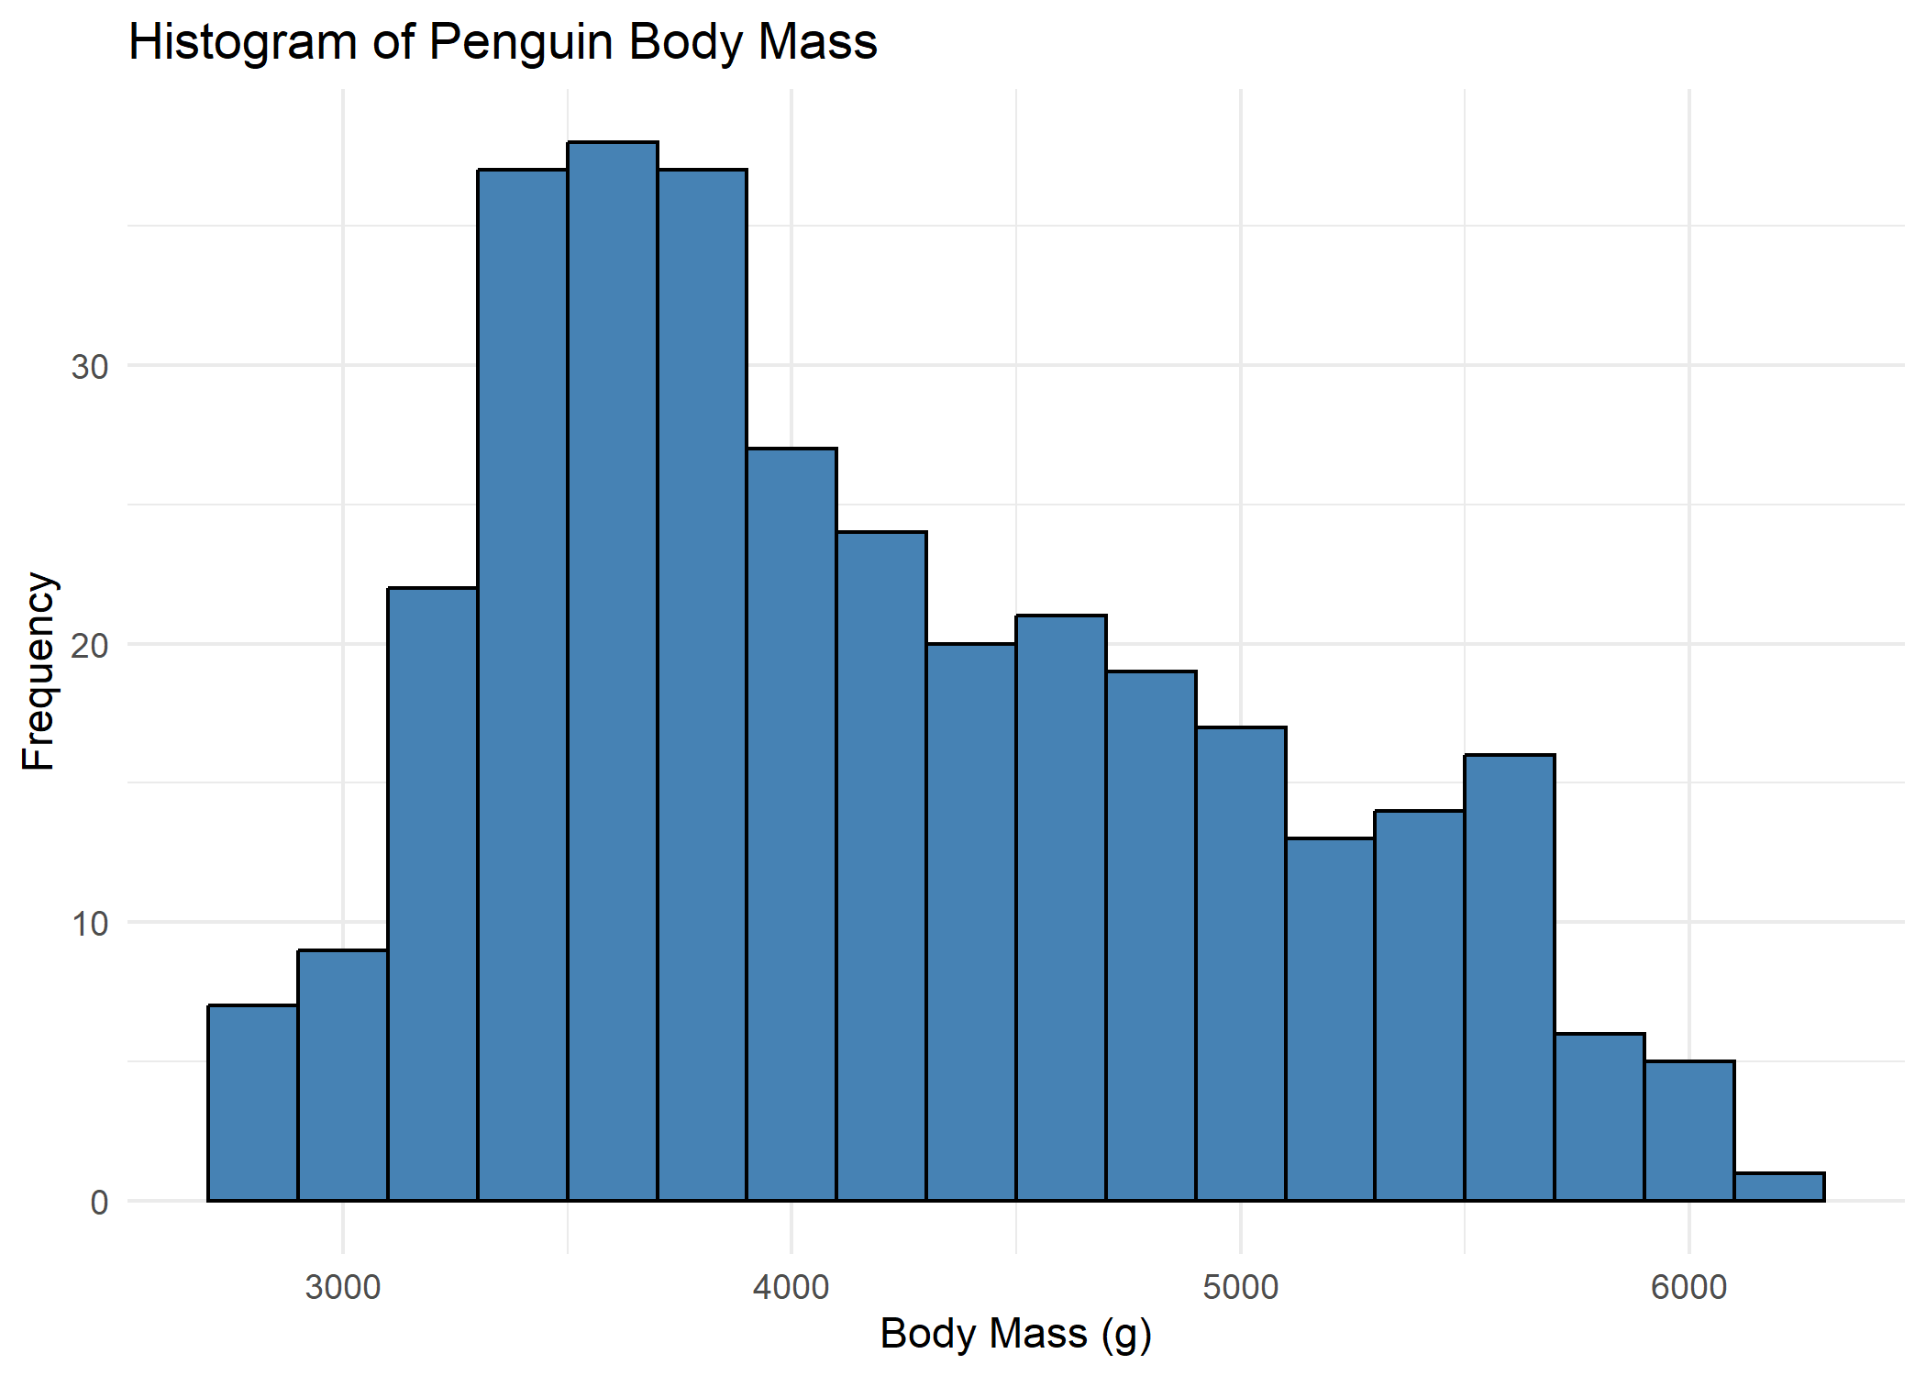
Figure 1. Histogram of overall penguin body mass, showing a bimodal-leaning distribution driven by the heavier Gentoo subgroup.
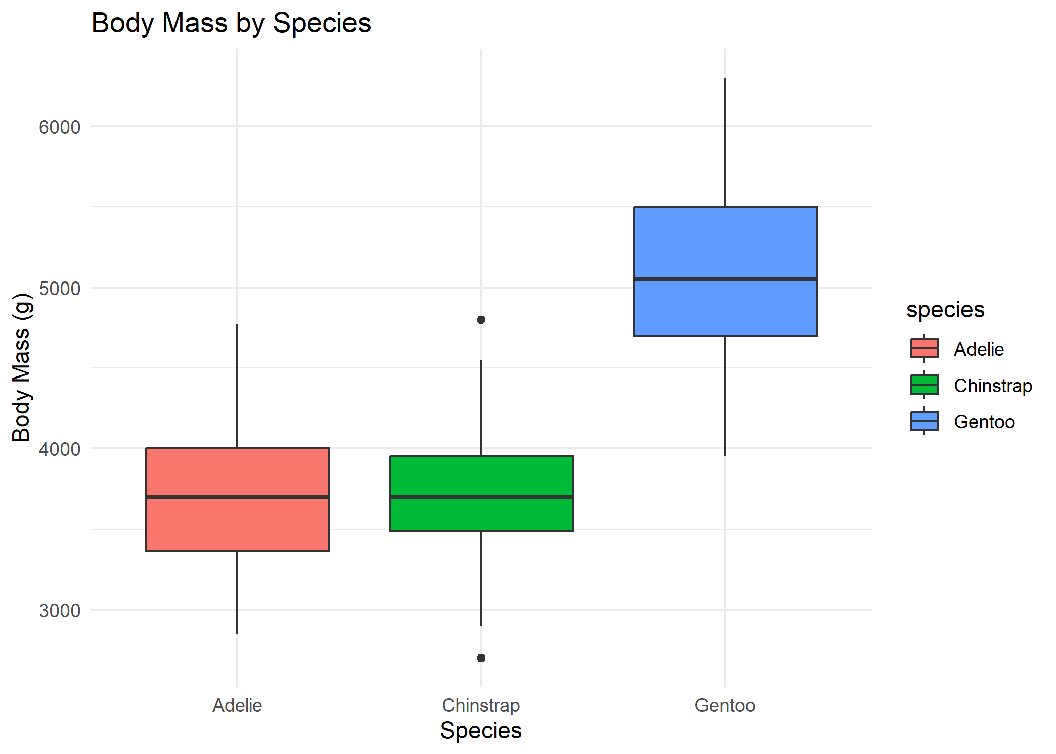
Figure 2. Boxplot of body mass by species. Gentoo penguins are visibly heavier and more variable than Adelie or Chinstrap.
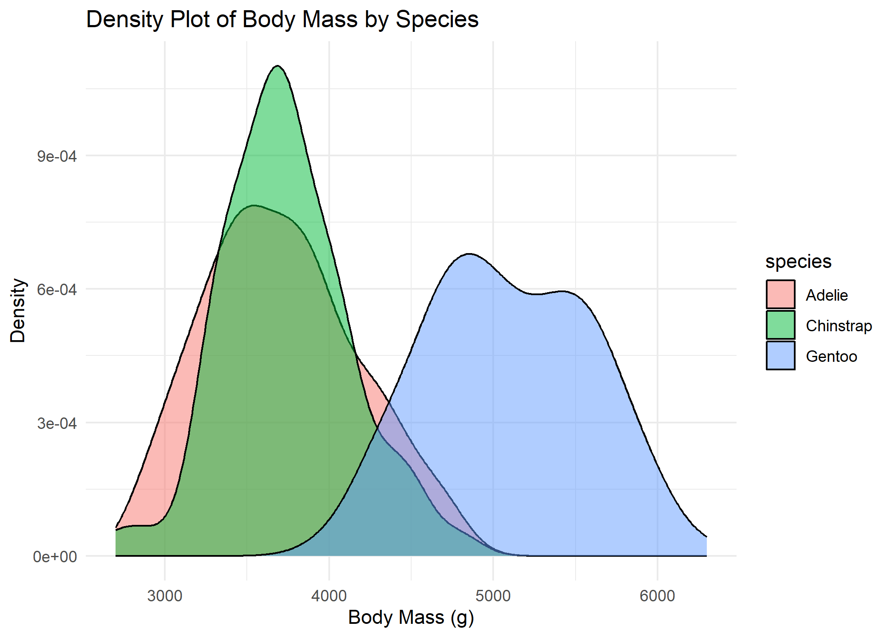
Figure 3. Density plot of body mass by species. Adelie and Chinstrap distributions overlap substantially; Gentoo is clearly separated.

3. Hypothesis Testing — Male vs Female Body Mass

3.1 Hypotheses
- H0 (null): The mean body mass of male penguins is equal to the mean body mass of female penguins.
- H1 (alternative): The mean body mass of male penguins is not equal to the mean body mass of female penguins.

3.2 Normality Assumption
Shapiro-Wilk tests were run separately on male and female body mass. For males, W = 0.925, p = 1.23 × 10⁻⁷; for females, W = 0.919, p = 6.16 × 10⁻⁸. Both p-values are far below 0.05, indicating a statistically significant departure from normality in both groups. The QQ-plots below confirm this: points deviate from the reference line at both tails, consistent with the bimodality introduced by mixing multiple species within each sex group.
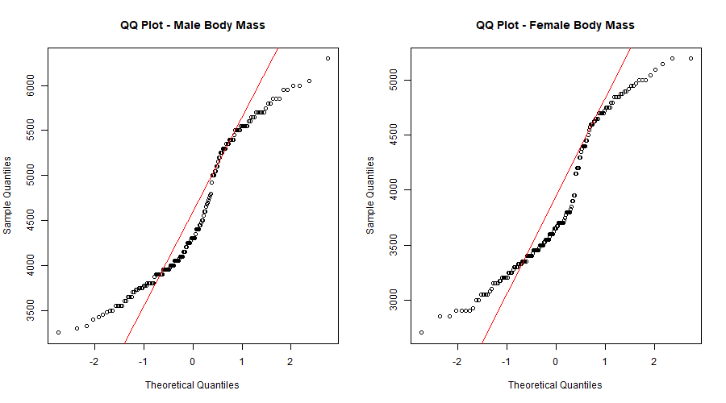
Figure 4. QQ-plots for male (left) and female (right) body mass. Departures from the red reference line indicate non-normality.

3.3 Two-Sample t-test
Despite the normality violation, Welch's two-sample t-test was used, as it is reasonably robust to non-normality with these sample sizes (n = 168 male, n = 165 female) and does not assume equal variances. Result: t = −8.5545, df = 323.9, p = 4.79 × 10⁻¹⁶.
Group | Mean Body Mass
Female | 3862.27 g
Male | 4545.69 g

3.4 95% Confidence Interval
The 95% confidence interval for the difference in mean body mass (female − male) is [−840.58, −526.25] g. Since this interval excludes zero, the difference is statistically significant.

3.5 Effect Size — Cohen's d
Cohen's d = 0.936, which falls in the "large" effect-size range (conventionally: <0.2 negligible, 0.2–0.5 small, 0.5–0.8 medium, >0.8 large).

3.6 Interpretation
The p-value (4.79 × 10⁻¹⁶) is far below the 0.05 significance threshold, so the null hypothesis is rejected: male and female penguins differ significantly in mean body mass. Male penguins are, on average, about 683 g heavier than females. The 95% confidence interval confirms this difference is unlikely to be zero, and Cohen's d of 0.936 indicates the difference is not just statistically significant but also practically large — sex is a strong predictor of body mass in this dataset, independent of species.

4. One-Way ANOVA — Body Mass Across Species

4.1 Assumption Checks
Shapiro-Wilk normality tests per species: Adelie (W = 0.981, p = 0.042), Gentoo (W = 0.986, p = 0.261), Chinstrap (W = 0.984, p = 0.561). Adelie shows a marginally significant departure from normality (p just under 0.05); Gentoo and Chinstrap do not depart significantly. The QQ-plots below broadly support approximate normality within each species, with only minor tail deviations.
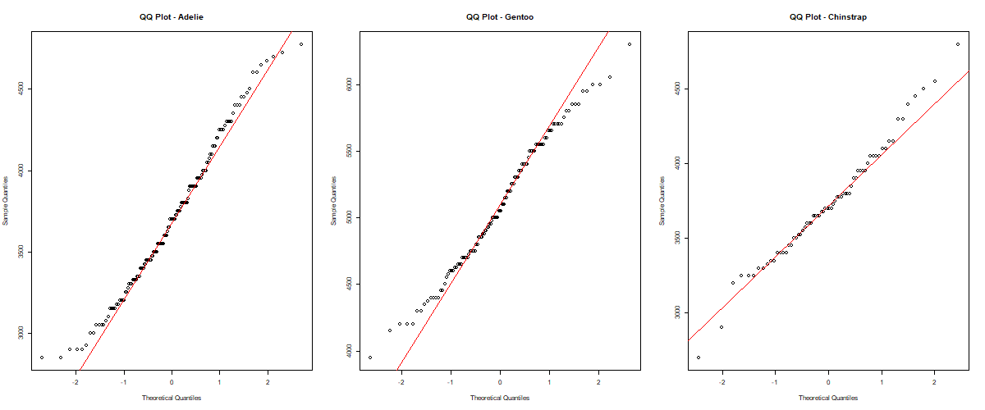
Figure 5. QQ-plots of body mass for Adelie, Gentoo, and Chinstrap. Points track close to the reference line, indicating approximate normality.
Levene's test for homogeneity of variance: F(2, 330) = 5.135, p = 0.0064. This is below 0.05, indicating variances are NOT equal across species — a mild-to-moderate violation of the equal-variance assumption underlying classical one-way ANOVA.

4.2 One-Way ANOVA Result
Source | Df | Sum Sq | Mean Sq | F value | Pr(>F)
Species | 2 | 145,190,219 | 72,595,110 | 341.9 | < 2e-16
Residuals | 330 | 70,069,447 | 212,332

The F-statistic (341.9) with 2 and 330 degrees of freedom yields p < 2 × 10⁻¹⁶, a highly significant result. Mean body mass differs significantly among the three penguin species.

4.3 Tukey HSD Post-Hoc Test
Since the ANOVA was significant, Tukey's HSD test was run to identify which species pairs differ:
Comparison | Diff | Lower CI | Upper CI | p adj
Chinstrap − Adelie | 26.92 g | −132.35 | 186.20 | 0.916
Gentoo − Adelie | 1386.27 g | 1252.29 | 1520.26 | < 0.001
Gentoo − Chinstrap | 1359.35 g | 1194.43 | 1524.27 | < 0.001

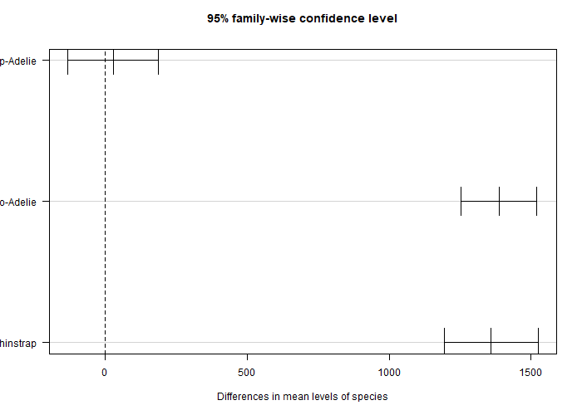
Figure 6. Tukey HSD 95% family-wise confidence intervals. Intervals not crossing zero indicate significant pairwise differences.
Gentoo penguins differ significantly in body mass from both Adelie and Chinstrap (p < 0.001 for both comparisons), while Adelie and Chinstrap do not differ significantly from each other (p = 0.916). This matches the visual separation seen in the boxplots and density plots in Section 2.

5. Non-Parametric Analysis — Kruskal-Wallis Test
Given the significant Levene's test result (unequal variances) and the borderline Shapiro-Wilk result for Adelie, a Kruskal-Wallis test was run as a robustness check on body mass across species: χ² = 212.09, df = 2, p < 2.2 × 10⁻¹⁶.
Test | Statistic | p-value | Conclusion
One-Way ANOVA | F = 341.9 | < 2.2e-16 | Reject H0
Kruskal-Wallis | χ² = 212.09 | < 2.2e-16 | Reject H0

Both the parametric (ANOVA) and non-parametric (Kruskal-Wallis) tests lead to the same conclusion: body mass differs significantly across the three penguin species. This agreement gives confidence that the ANOVA finding is robust even though the equal-variance assumption was mildly violated.

6. Two-Way ANOVA — Species × Sex on Body Mass
A two-way ANOVA was fitted using body_mass_g ~ species * sex to examine the individual and combined effects of species and sex on body mass:
Source | Df | Sum Sq | Mean Sq | F value | Pr(>F)
Species | 2 | 145,190,219 | 72,595,110 | 758.36 | < 2e-16
Sex | 1 | 37,090,262 | 37,090,262 | 387.46 | < 2e-16
Species:Sex | 2 | 1,676,557 | 838,278 | 8.76 | 0.000197
Residuals | 327 | 31,302,628 | 95,727

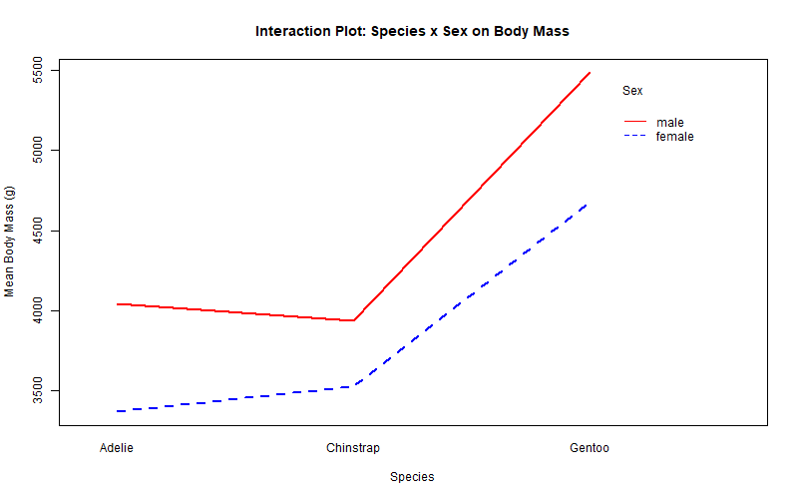
Figure 7. Interaction plot of species and sex on mean body mass. Non-parallel lines indicate an interaction effect.

Interpretation
- Species has a highly significant main effect on body mass (F = 758.36, p < 2e-16) — species is the dominant driver of body mass differences.
- Sex has a highly significant main effect on body mass (F = 387.46, p < 2e-16) — males are heavier than females across species.
- The species:sex interaction is also statistically significant (F = 8.76, p ≈ 0.0002), meaning the size of the male-vs-female difference is not the same across all three species — visible in the interaction plot as the steeper gap for Gentoo compared to Adelie and Chinstrap.
In practical terms: both species and sex independently influence body mass, and the sex-based weight gap widens for the larger-bodied Gentoo species relative to the other two.

7. Additional Analysis — Flipper Length by Species
Species | Mean | SD | Min | Max
Adelie | 190 mm | 6.52 mm | 172 mm | 210 mm
Chinstrap | 196 mm | 7.13 mm | 178 mm | 212 mm
Gentoo | 217 mm | 6.59 mm | 203 mm | 231 mm

Shapiro-Wilk tests: Adelie (W = 0.993, p = 0.743) and Chinstrap (W = 0.989, p = 0.811) show no significant departure from normality; Gentoo shows a significant departure (W = 0.961, p = 0.0018). Levene's test for homogeneity of variance was not significant (F = 0.443, p = 0.643), indicating equal variances across species — a cleaner assumption profile than for body mass.
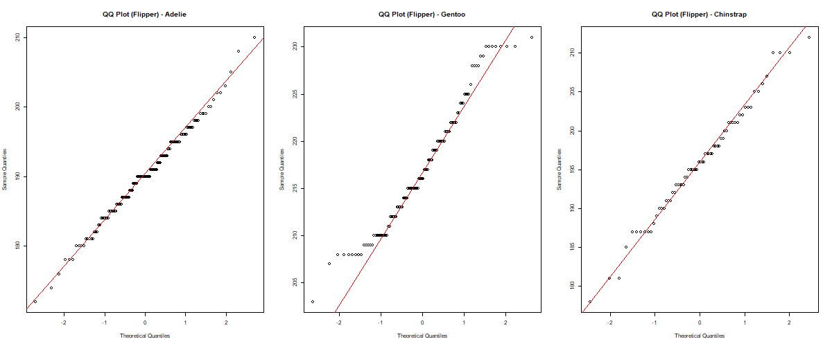
Figure 8. QQ-plots of flipper length by species. Adelie and Chinstrap track the reference line closely; Gentoo shows minor tail deviation.

One-Way ANOVA — Flipper Length
Source | Df | Sum Sq | Mean Sq | F value | Pr(>F)
Species | 2 | 50,526 | 25,263 | 567.4 | < 2e-16
Residuals | 330 | 14,693 | 45

Tukey HSD — Flipper Length
Comparison | Diff | Lower CI | Upper CI | p adj
Chinstrap − Adelie | 5.72 mm | 3.41 | 8.03 | 0.000
Gentoo − Adelie | 27.13 mm | 25.19 | 29.07 | 0.000
Gentoo − Chinstrap | 21.41 mm | 19.02 | 23.80 | 0.000

Kruskal-Wallis (robustness check): χ² = 237.35, df = 2, p < 2.2 × 10⁻¹⁶ — consistent with the ANOVA finding.
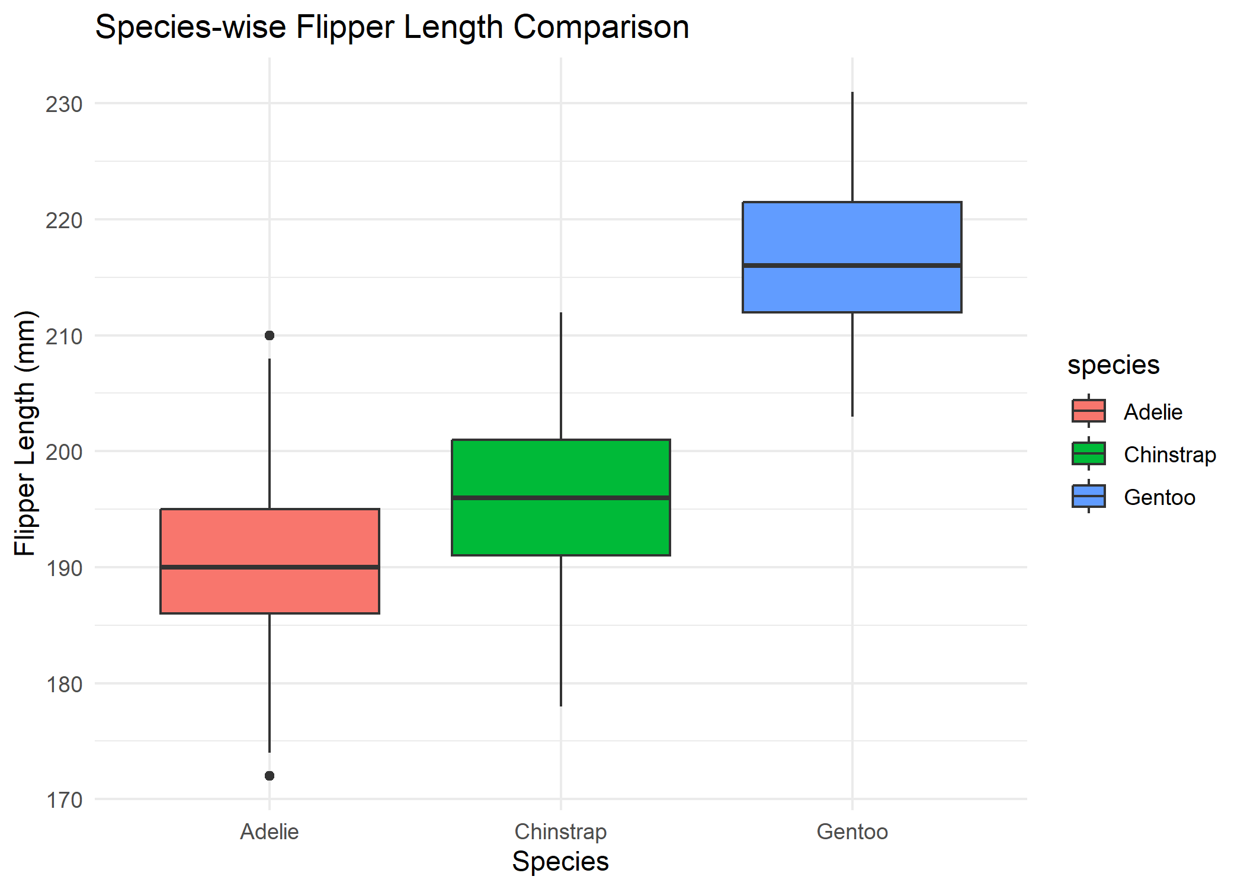
Figure 9. Species-wise boxplot of flipper length, showing Gentoo with the longest and most distinctly separated flippers.
Unlike body mass, ALL pairwise species comparisons are significant for flipper length — including Chinstrap vs Adelie (p < 0.001), which was not significant for body mass. This shows flipper length discriminates between all three species, while body mass only clearly separates Gentoo from the other two. Both traits agree that Gentoo is the most physically distinct species, consistent with its larger overall body size.

8. Additional Visualizations
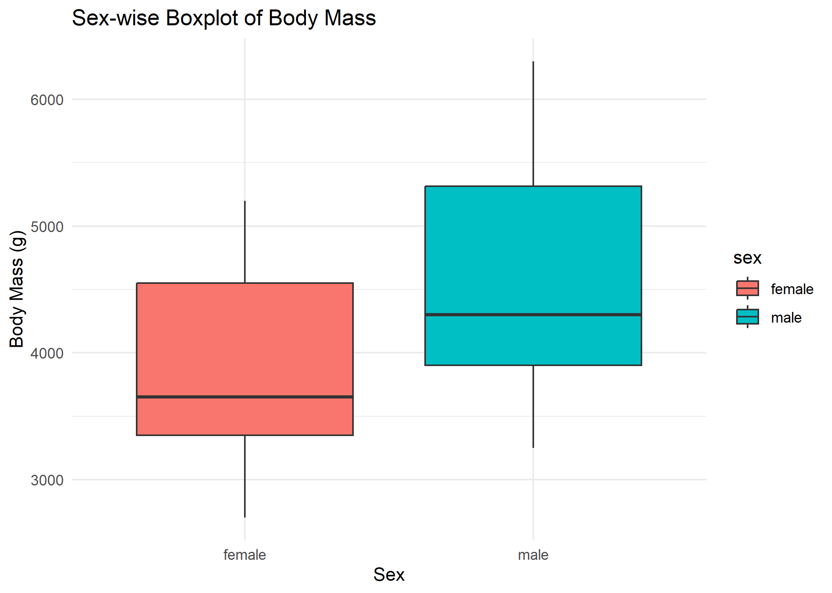
Figure 10. Sex-wise boxplot of body mass, showing males with a higher median and wider spread than females.
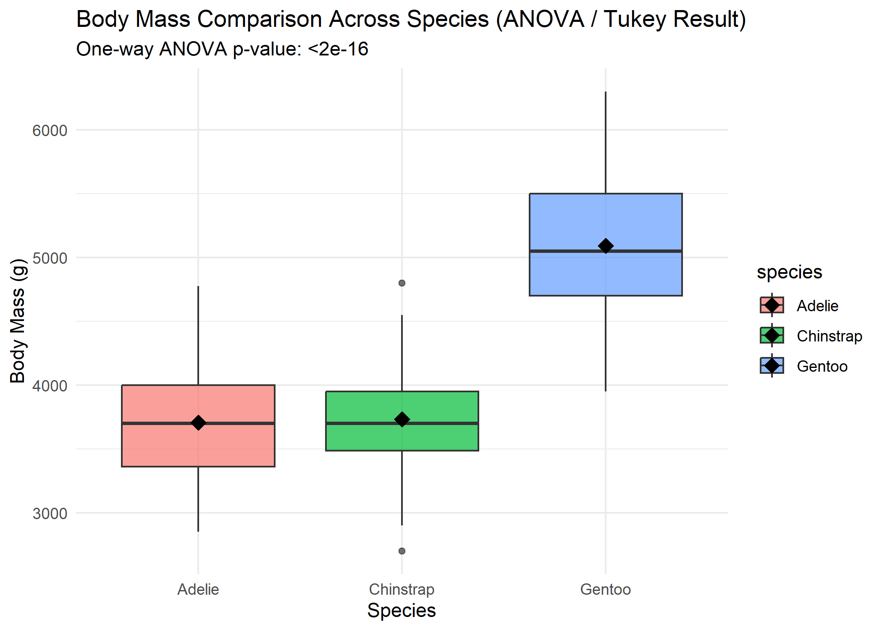
Figure 11. Body mass comparison across species with group means (diamonds) overlaid, annotated with the one-way ANOVA p-value.

9. Overall Conclusions
- Species is the strongest determinant of penguin body mass and flipper length: Gentoo penguins are substantially heavier and larger-flippered than Adelie and Chinstrap, which are statistically indistinguishable from each other on body mass alone but do differ significantly on flipper length.
- Sex significantly affects body mass across all species, with males averaging about 683 g heavier than females (large effect size, Cohen's d = 0.936).
- There is a significant species × sex interaction: the male–female body mass gap is more pronounced in Gentoo than in Adelie or Chinstrap.
- Parametric (ANOVA) and non-parametric (Kruskal-Wallis) tests agree in every case, indicating the conclusions are robust to the mild normality and variance violations observed.
- Flipper length is a more consistent species discriminator than body mass, since it significantly separates all three species pairwise, whereas body mass does not separate Adelie from Chinstrap.
Taken together, these results confirm that both body mass and flipper length vary meaningfully by species and sex among Palmer Archipelago penguins, with Gentoo penguins standing out as the largest and most distinct group, and male penguins consistently outweighing females within each species.

